A longtime pianist and church organist, Nebel has directed music and accompanied services for eight congregations over the last eighteen years. In addition to teaching at CSU Pueblo, he teaches piano, horn, organ, and music theory at the Pirisen Academy and runs a private studio in Lakewood, CO. Nebel is a NASM-certified personal trainer, a graduate of the National Personal Training Institute of Colorado, a 200-hour Yoga Alliance instructor, and recently completed a Doctorate of Music at the University of Northern Colorado specializing in postural studies of horn players. Nebel holds degrees in music performance from the Eastman School of Music and Wichita State University. He enjoys hiking, backpacking, trail running, cycling, skiing, and rock climbing with his wife Erin in the beautiful public lands of the Western United States.

Native of Sofia, Bulgaria, Dr. Metchkov holds DMA in piano performance from the Cleveland Institute of Music, Cleveland, Ohio. He is a Professor of Music at Colorado State University Pueblo, teaching applied piano, chamber music, and pedagogy. Besides music, Zahari has pursued Bonsai for the last seven years and in Fall 2024, Zahari is teaching the inaugural “Introduction to Bonsai” class at CSU Pueblo, a 1 credit offering of the Creative Wellness Minor program.
www.zaharimetchkov.com | @Ponderosapine

Piano Conversations Board Members:
Saskia Aevum, Jeanette Cortez, Jennifer Shadle, Christine Ortega, Zahari Metchkov

Piano Conversations expresses their gratitude to Dennis Moore and Hoag Hall Crue, and Dr. Mark Hudson, Chair of Music Department, CSUP

Save the Date!!!!!

May 2, Saturday, 7.00pm
Hoag Recital Hall
Hammers, Mallets, Drums, and Gongs…..
Music for Two Pianos and Percussion (lots of percussion) 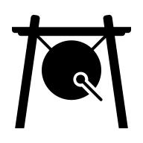

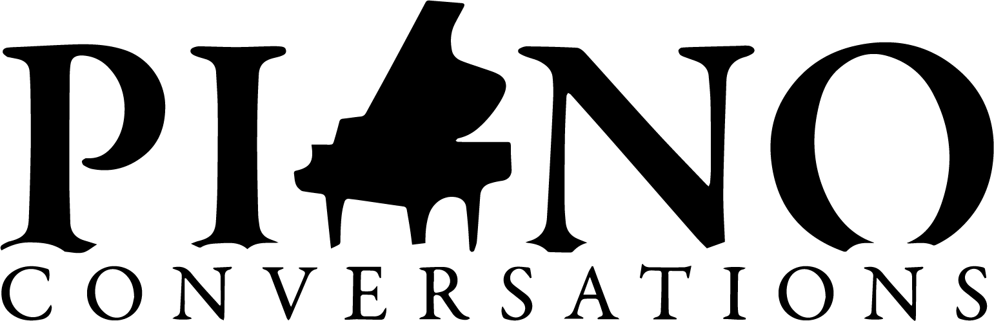
Saturday, September 7
7.00 p.m., 2026

Winds of Change

Hoag Recital Hall
CSU Pueblo, Colorado

Admission: $20, cash or check
Students free with ID

Piano Conversations is formed with the express and sole purpose of establishing an environment in southern Colorado to enhance and enable the presentation and appreciation of classical music.
Piano Conversations is a 501 (c) (3) non-profit organization.

BIOGRAPHIES
Andrea Artley became Adjunct Professor of Flute at CSU-Pueblo in 2014. From 1987 until 2013, Andrea was a flutist with the U.S. Army Band "Pershing's Own" in Washington, D.C. From 2000 to 2013, she was principal flute and soloist with the organization performing in venues across the U.S., Europe, and China. During her years with "Pershing's Own," Andrea was an active chamber musician, performing at the White House, Capitol, State Department and the Library of Congress. Andrea earned a degree in flute performance from DePaul University in Chicago. She resides with her husband and two children in Monument, Colorado. Andrea performs regularly as Co-Principal Flute with the Pueblo Symphony. She also plays with the Steamboat Symphony and has been a substitute flutist with the Colordo Springs Philharmonic. Ms. Artley collaborates with guitarist and CSU-P faculty member, Ben Johnson. Their duo, The Mountain Aire Duo can be heard in recital throughout the area. Andrea Artley is a Miyazawa Performing Artist

Josh Goo loves to share his passion for music through energetic performances, engaging content, and thoughtful teaching. He regularly performs world premieres and other contemporary classical music with the Denver based Nebula Ensemble as their Clarinetist and Artistic Director. He has played principal clarinet with the Sheridan Solisti Orchestra, Aspen Philharmonic Orchestra, Lamont Symphony Orchestra, Denver Young Artists Orchestra, Northwestern’s Symphonic Wind Ensemble, and the North Shore Concert Band.After learning so much from his incredible teachers like Steve Cohen, Michael Rusinek, Dr. Jeremy Reynolds, and Charles Neidich, while getting his Masters from Northwestern University, Bachelors from the University of Denver, and attending festivals such as the Aspen Summer Music Festival and Domaine Forget, he is honored to be able to pass that knowledge on to others. As the creator of QuickStart Clarinet, he inspires a deeper understanding of the clarinet and music in weekly video content, online courses and memberships, as well as traditional private lessons, so that we can find more joy in our music and make the world more beautiful.

Dr. Michael L. Johnson is a Colorado Springs based oboist and teacher. He currently performs as oboist with the United States Air Force Academy Band. Prior to his current position, he was the solo English horn of the Tucson Symphony Orchestra. He has also performed as a guest with numerous orchestras and ensembles such as the Phoenix Symphony, Arizona Opera, Austin Symphony, Arizona Philharmonic, Modesto Symphony, Music in the Mountains, Victoria Bach Festival, and the Arizona Bach Festival. He has also spent summers at the Aspen Music Festival, Eastern Music Festival, Miami Music Festival, and Domaine Forget Academy. He holds a Masters and Bachelors of Music Performance from McGill University and the Manhattan School of Music respectively, and recently completed his Doctorate in Oboe Performance at Arizona State University. His thesis titled “French Court Music: A Modern Performance Approach, Compendium to P.D. Philidor’s Trio Suite No. 2 in E Minor” centered on accessibility and adaptation of music from the court of Louis XIV, as well as chronicled the history of the Philidor family of court composers. His primary teachers include Robert Botti, Theodore Baskin, and Martin Schuring.

Dr. Dan Nebel is an accomplished French hornist, church organist, music director, and educator whose diverse career has taken him across the United States. Currently the principal horn of the Monterey Symphony and organist at Arvada United Methodist Church, he served as a bandsman with the United States Air Force Band of the Golden West for five years. He toured extensively throughout the Western United States including regular appearances at the Hollywood Bowl. Mr. Nebel currently freelances throughout Colorado, Wyoming, New Mexico, and California performing regularly with the Colorado Springs Philharmonic, New Mexico Philharmonic, and Cheyenne Symphony Orchestra. Dan has performed with the Buffalo Philharmonic Orchestra, Ohio Light Opera, Colorado College Summer Music Festival, and New York String Orchestra Seminar, and has held positions with the Wichita Symphony Orchestra, Wichita Grand Opera, North State Symphony, and Fort Collins Symphony.

Program
Sarabande et Minuet, Op. 72
Vincent d’Indy (1851-1931)

Sextet for Piano, Flute, Oboe, Clarinet, Horn and Bassoon
Gordon Jacob (1895-1984)

Elegiac Prelude
Scherzo
Cortege
Minuet and Trio
Rondo with Epilogue

INTERMISSION

Tarantella for Flute, Clarinet, and Piano Op. 6 
Camille Saint-Saens (1835-1921)

Sextet for Flute, Oboe, Clarinet, Bassoon, Horn & Piano
Francis Poulenc (1899-1963)

Allegro Vivache
Divertissment
Finale

The Ensemble:
Andrea Artley-flute
Josh Goo-clarinet
Michael Johnson-oboe
Daniel Nebel-horn
Carl Gardner-bassoon
Zahari Metchkov-piano

