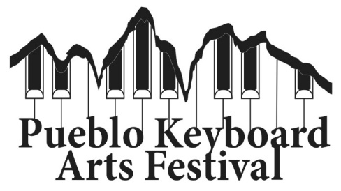
Dear Colleagues,
It is with great excitement that we at Colorado State University Pueblo look forward to the 16th annual Pueblo Keyboard Arts Festival, scheduled to take place Nov. 5 - Nov. 7, 2026. Combining quality musical programs with educational opportunities for young and college age pianists, we hope to provide a welcoming platform for all interested in immersing themselves in the art of keyboard playing. It is my hope that participants and audience will find this Festival serves as a source of inspiration, knowledge, and one of the many elements that lead to the growth of the "complete musician."

November 6, Piano Masterclasses 6:00 p.m. to 8:00 p.m.
Open to Middle/High/Collegiate School Students.
November 7 PKAF Young Artist Competition, 9:00 a.m.
Offers cash prizes in the Junior and Senior, Solo and Ensemble divisions.
November 7, “Monster” Piano Concert, 7:00 p.m.
An all-piano extravaganza featuring faculty, guest artists from around the state, current CSU Pueblo students, alumni, and friends.
~
Please don't hesitate to contact us: Dr. Zahari Metchkov, zahari.metchkov@csupueblo.edu, 719-565-8855
Application form and information can be found at: www.csupueblo.edu/music/festivals or www.zahari.metchkov.com/festivals

2026 FESTIVAL ARTISTS:
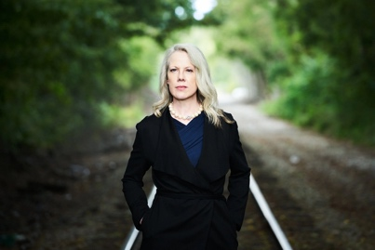
Caroline Oltmanns is a pianist, presenter, and pedagogue known for her imaginative interpretations, refined phrasing, and engaging stage presence. Praised for her “fantasy” (Bayerischer Rundfunk) and “clear, light, and scintillating tone” (Pizzicato), she has performed widely throughout the United States and Europe. She has released seven solo CDs on the Filia Mundi label, including her 2022 concept album WIND, recorded at the Reitstadel in Germany. Recent seasons feature concert appearances in the US, Switzerland, and the UK, as well as past concerto engagements with the Youngstown Symphony, Cleveland Philharmonic, and others. She has presented recitals at venues such as Steinway Hall and Weill Recital Hall in New York, Preston Bradley Hall in Chicago, and the Redlands Bowl in Los Angeles. A committed advocate for new music, Oltmanns has commissioned and premiered numerous works and is frequently featured on international radio and television. She is Professor of Piano at Youngstown State University, has taught master classes worldwide, and has served as a jury member for several international piano competitions. Her philanthropic work includes founding 88 Hearts for Youngstown to support student piano scholarships. Born in Germany, she studied in Freiburg and at the University of Southern California as a Fulbright Scholar. Her musical mentors were Robert Levin, John Perry, and Vitaly Margulis. She is an International Steinway Artist, a Steinway Spirio Recording Artist, and a recipient of the 2022 and 2025 Steinway Top Teacher Awards.

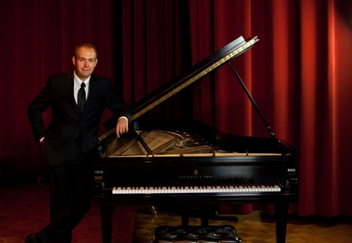
Zahari Metchkov, PKAF Artistic Director: Native of Sofia, Bulgaria, Dr. Metchkov is a Professor of Music at CSU Pueblo teaching applied piano, piano pedagogy, and ensembles. Zahari captivates audiences as a concerto soloist, recitalist, and chamber musician, maintaining multifaceted concert career. He has served for over a decade the Colorado State MTA in a number of appointments, including President and VP for Conferences. Under his artistic leadership, Pueblo based non-profit “Piano Conversations” has delivered over 60 concerts in Southern Colorado cultivating appreciation for quality classical live performances. He holds BM, MM, and DMA in piano performance from the Cleveland Institute of Music, Cleveland, Ohio.

