Seoul, South Korea Summer Program at Soongsil University

Various scholarship opportunities are available.

Please contact Dr. Juyun (Joey) Cho at joey.cho@csupueblo.edu for more information.

Immerse yourself in a unique study abroad program featuring an enriching course, exclusive special lectures, captivating Korean cultural activities, and an exciting language exchange with local Soongsil students. This is your opportunity to blend academic excellence with unforgettable cultural experiences. Unleash your potential and broaden your horizons in the heart of South Korea's capital!

Soongsil University (https://www.youtube.com/watch?v=cX08B93qDE )
- Founded in 1897
- The oldest university in Korea
- Located in the heart of Seoul
- Undergraduate 14,000
Graduate 3,000
International 2,000
- Faculty 1,200
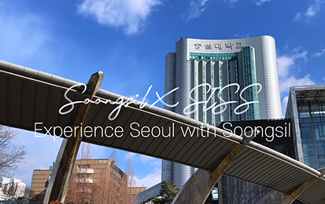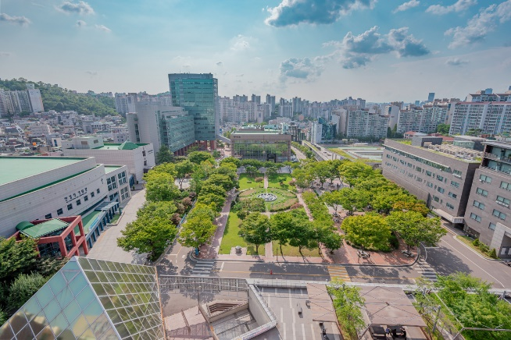

Seoul
- 4th most economically powerful city in the world
- 5th most populous in the world (Over 10 million people)
- 9th most visited city in the world (over 10 million international visitors every year)
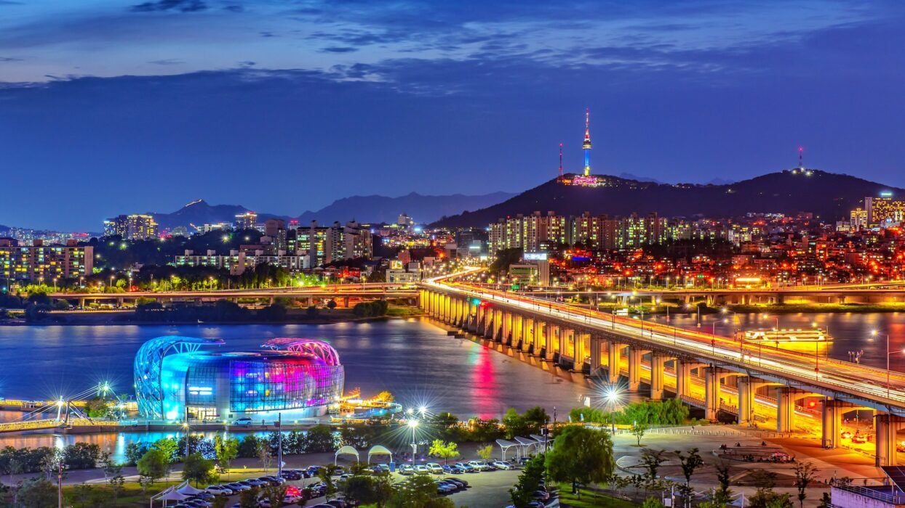

Courses (6 credits)
- CSU Pueblo CIS 491 Special Topics – AI, ChatGPT and Modern Technologies (3 credits) AND
- Korean Language (Beginner/Intermediate/Advanced) (3 credits) or
- Learning Korean through K-drama (3 credits) or
- Discover Korea: Politics, Economy and Culture (3 credits)

Stay in Soongsil University’s dorm for 4 weeks

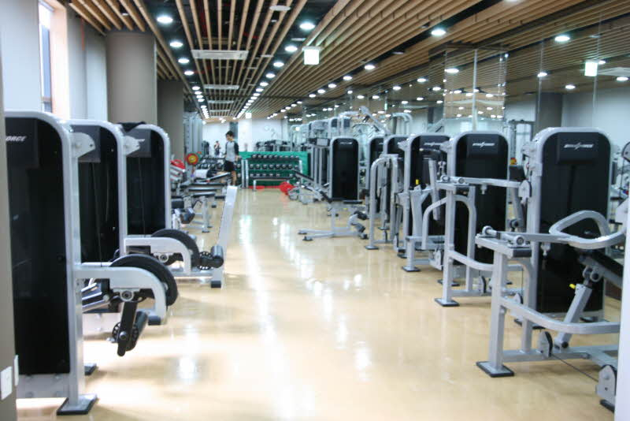

Social and Cultural Activities
- Gyeongbokgung Palace + Korean Traditional Clothes
- Seoul Tower Tour
- DMZ Tour
- Han River (Chimek)
- Lotte World Amusement Park
- Jeonju Hanok Village
- Han River Cruise

Promotional video
https://www.youtube.com/watch?v=DjX9fFNazB4&t=1s (created by Emmanuel Jeanmarie who attended the program in 2024)

and

